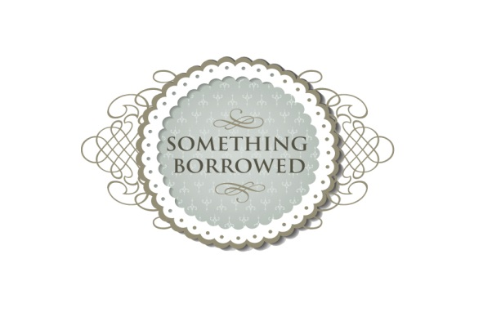
We have put together a couple of suggestions for a vintage package however our packages can be adjusted to suit your requirements and budget.
Package One
Butcher’s bike
Suitcase stack
Small step ladders - Fully decorated with vintage rose bowl, toilette bottles, garden pots, small flower jugs, pearlised tea light holders, cast iron love sign, antique glass picture frame.
(Items can be changed to include teapots, cups and saucers)
Underwood typewriter or Singer sewing machine
‘Cards’ suitcase or picnic basket
Camera
Phone
£110
Package Two
Butcher’s bike
Suitcase stack
Annie Sloan painted ladders - Fully decorated vintage rose bowl, toilette bottles, garden pots, small flower jugs, pearlised tea light holders, cast iron love sign, antique glass picture frame, vintage bird cage and large wooden wedding sign. (Items can be changed to include teapots, cups and saucers)
Underwood typewriter
Singer sewing machine
‘Cards’ suitcase or picnic basket
Gramophone
School desk & chair
Vintage style table plan / suitcase
Camera
Phone
£165
** Inquire about our Post box, bunting and china hire to compliment these packages**

